<http://transportation.uofnkona.edu/index.php>

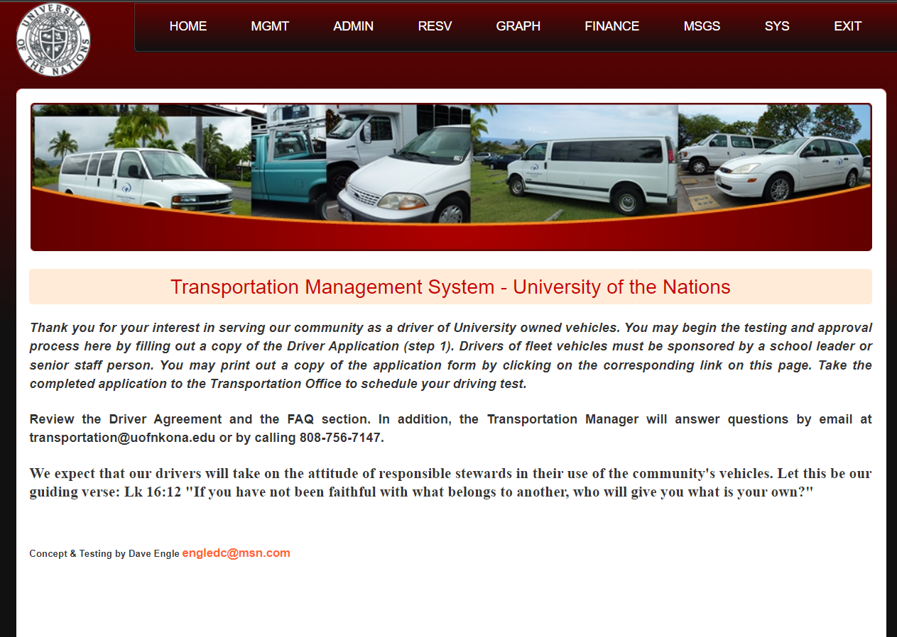

<http://transportation.uofnkona.edu/html/pending_trips_chart.php>

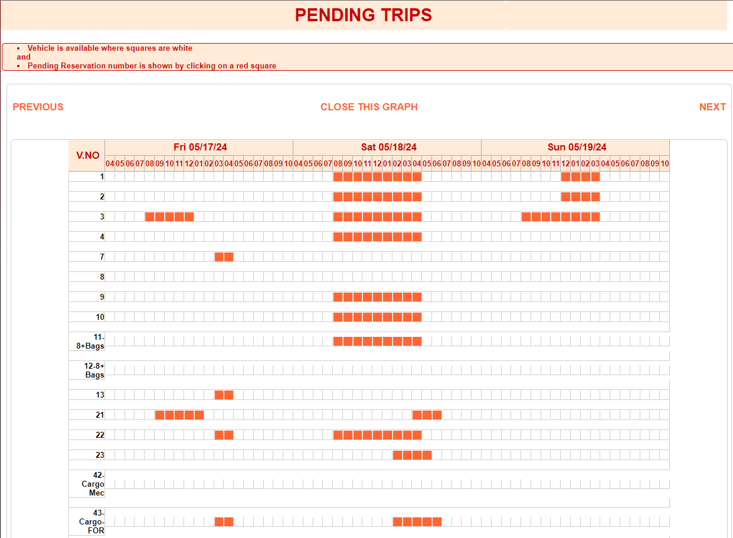

Important for an overview of what happens. What vehicles are available when. Important for booking, otherwise there is an endless trial.

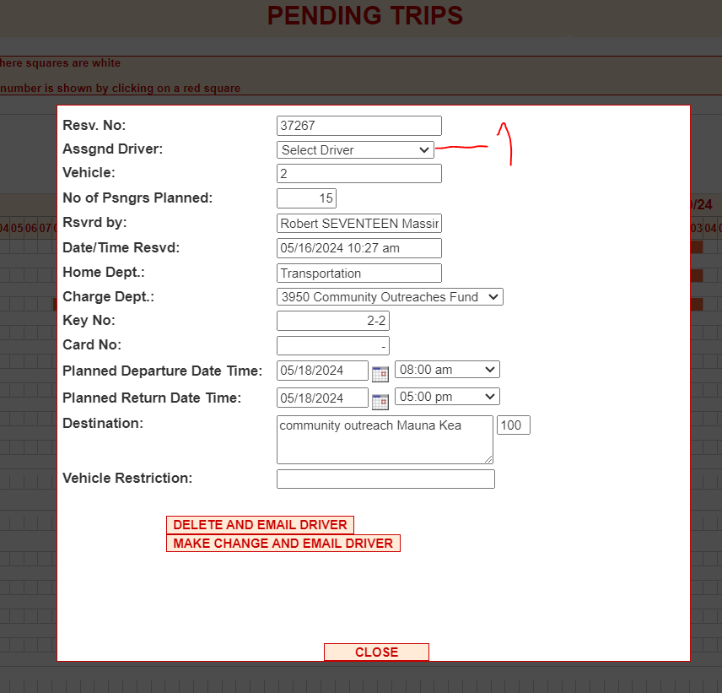

The view of one reservation. Notice that (1) is missing, so it is not possible to change the driver. This is wanted functionality.

http://transportation.uofnkona.edu/html/list_reports.php

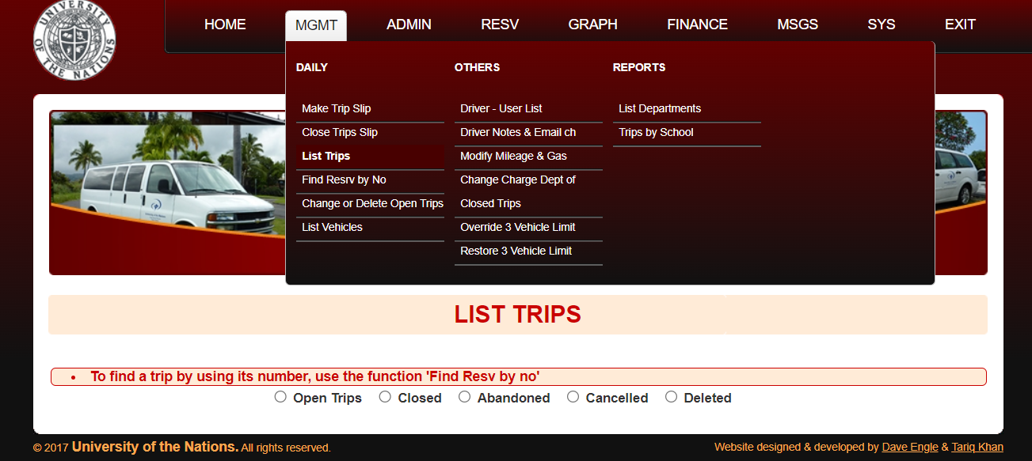

http://transportation.uofnkona.edu/html/list_reports.php

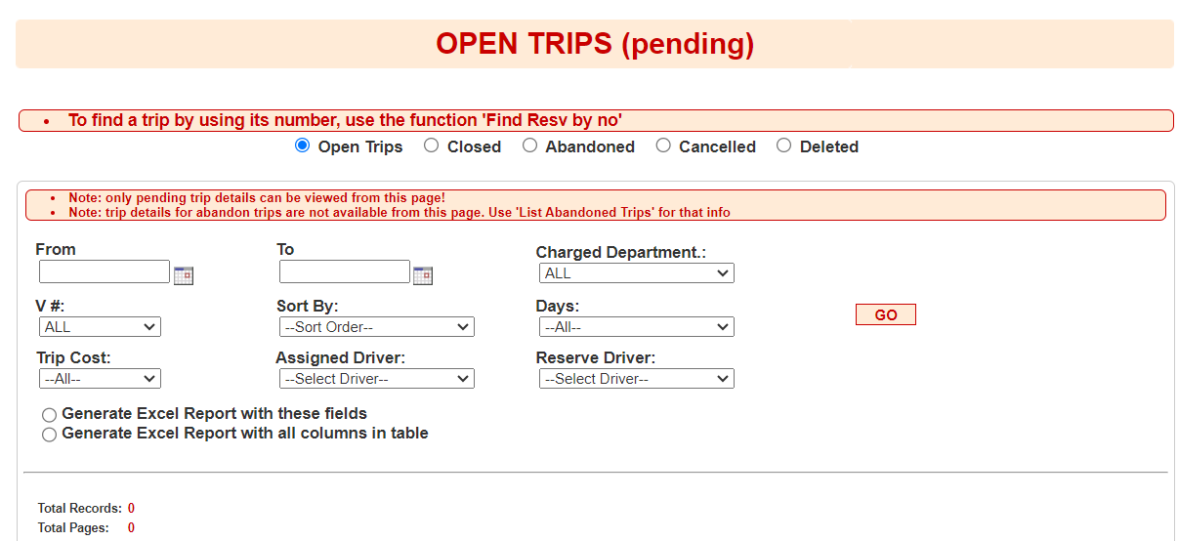

Uses “Open Trips” and “Closed”

Used in conjunction with the “Pending Trips” for overview.

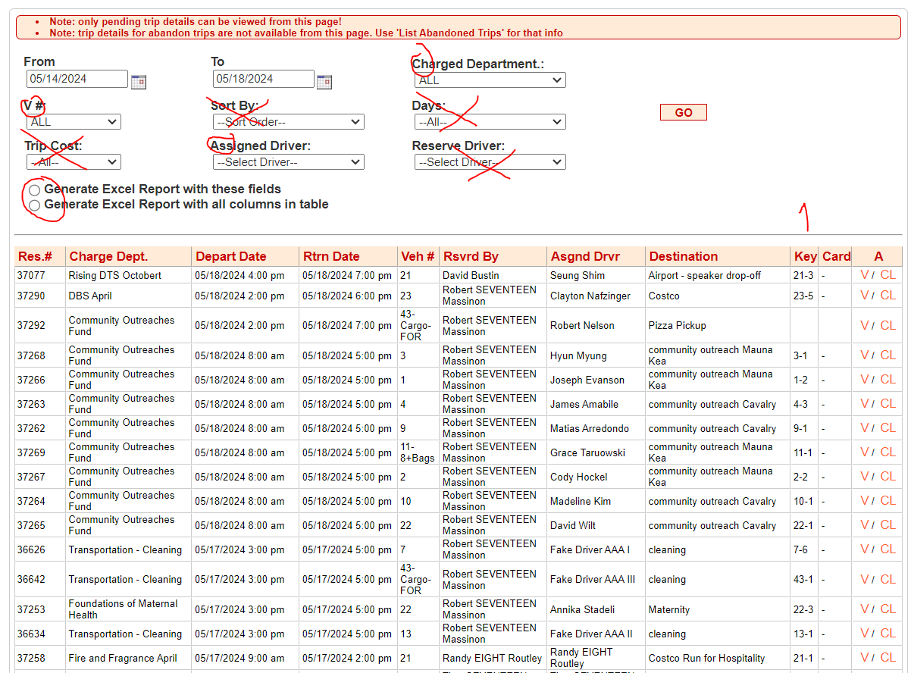

1. Is for charging for keys that where not delivered.

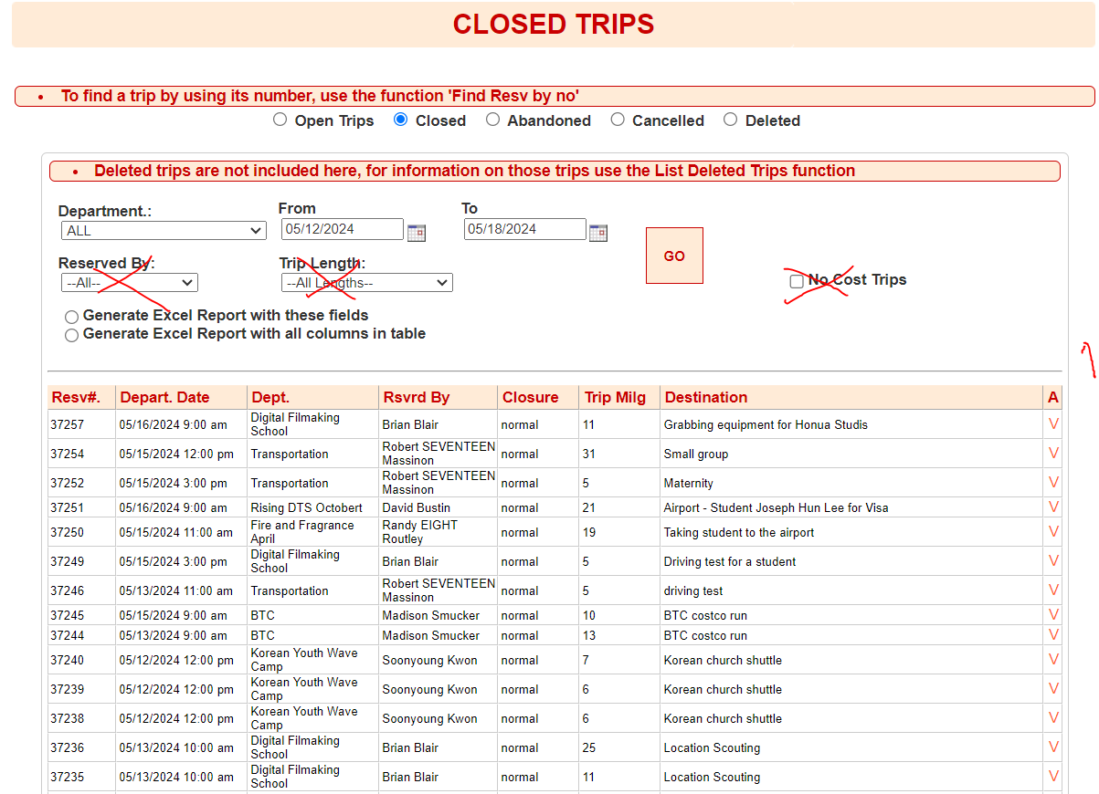

1. Missing fields are
   1. Key number
   2. Driver name

<http://transportation.uofnkona.edu/html/reservations.php>

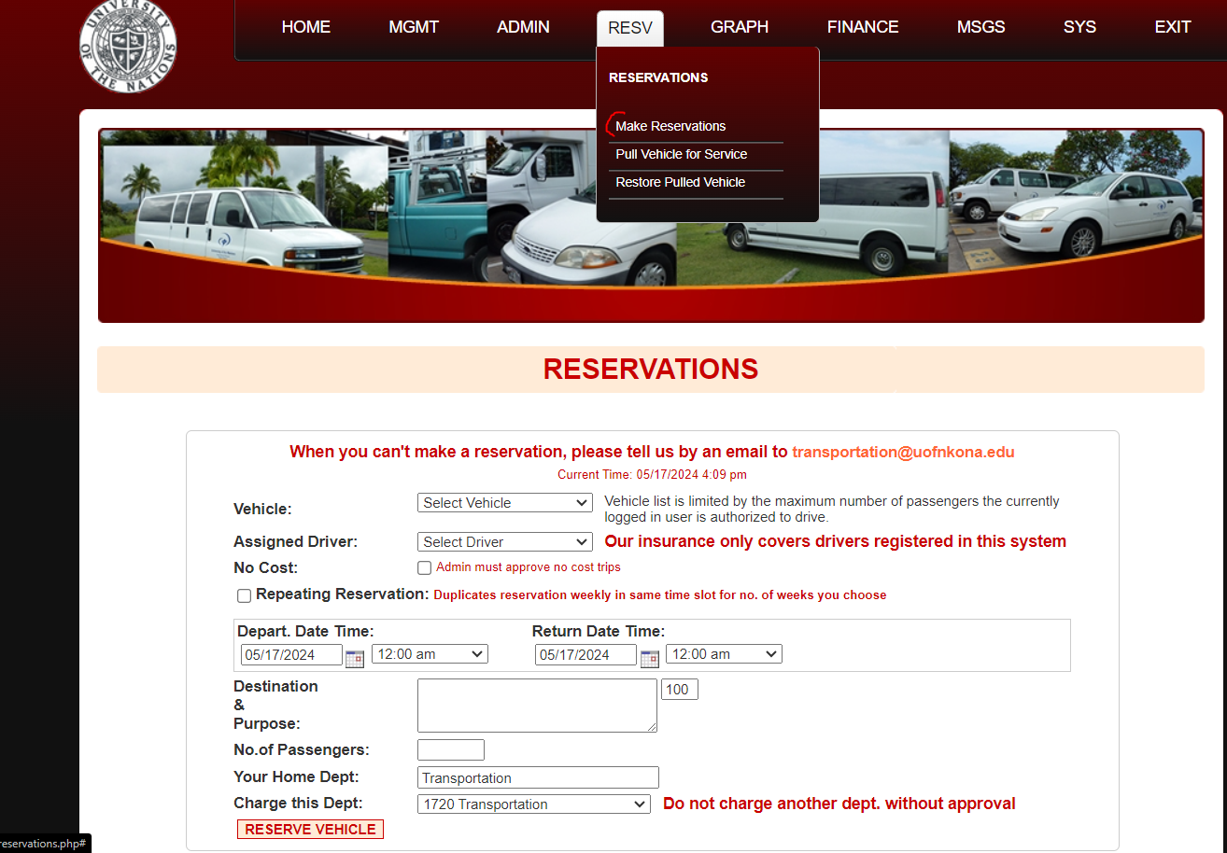

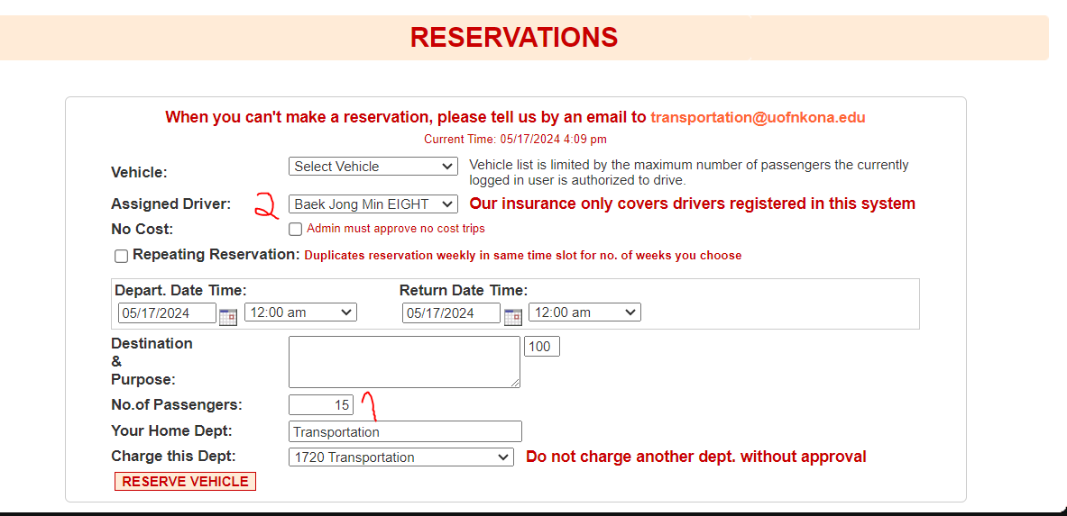

(1) should limit the listing in (2) according to the number of passengers that driver can have.

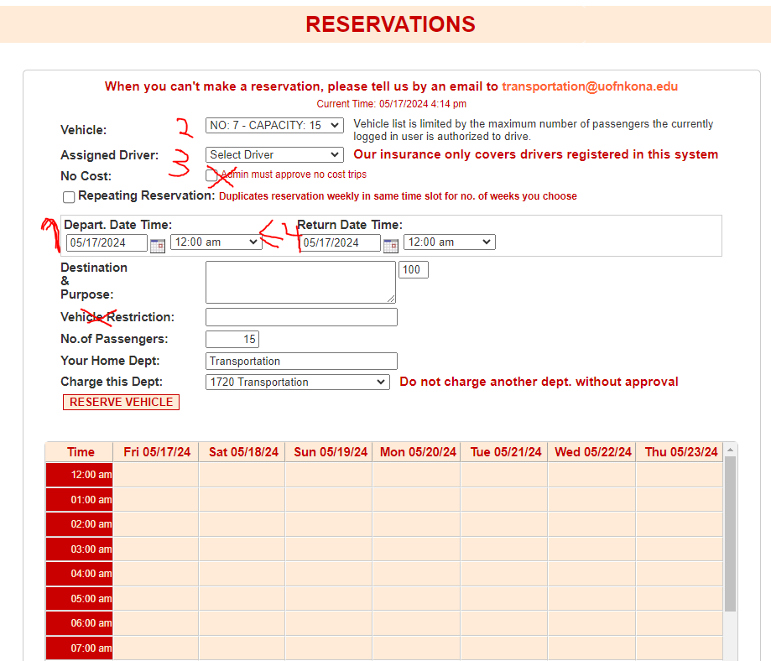

The logical order should match the physical order, currently the order of filling out is (1-2-3) or it will erase other fields. 4 should be after 1, not currently done.

<http://transportation.uofnkona.edu/html/add_keycard_trip.php>

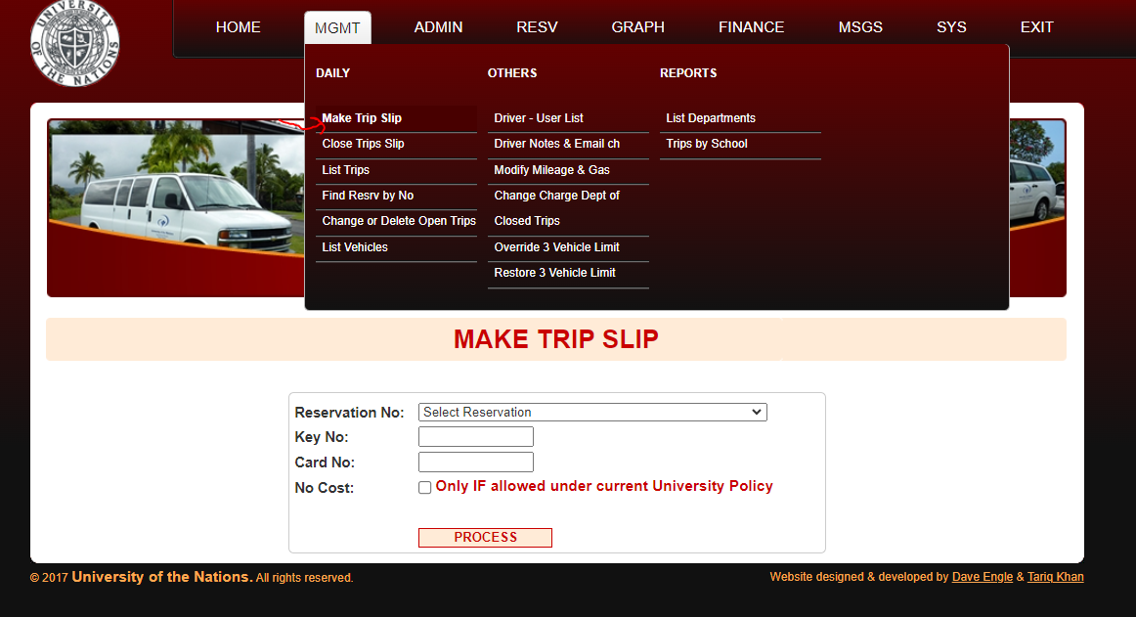

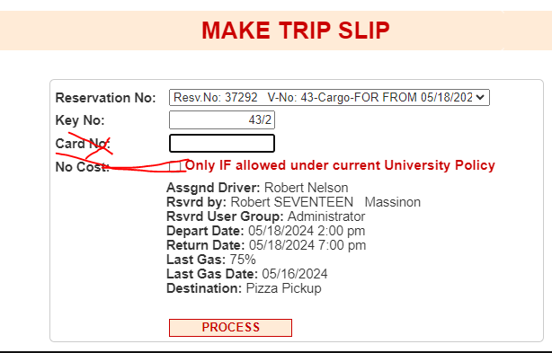

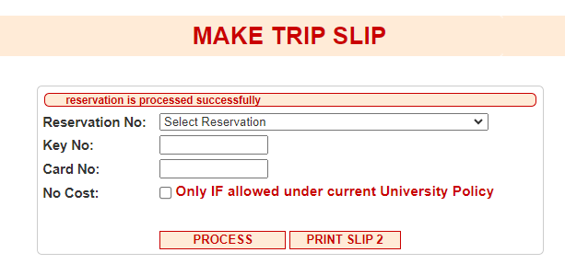

Non functional intermediate screen.

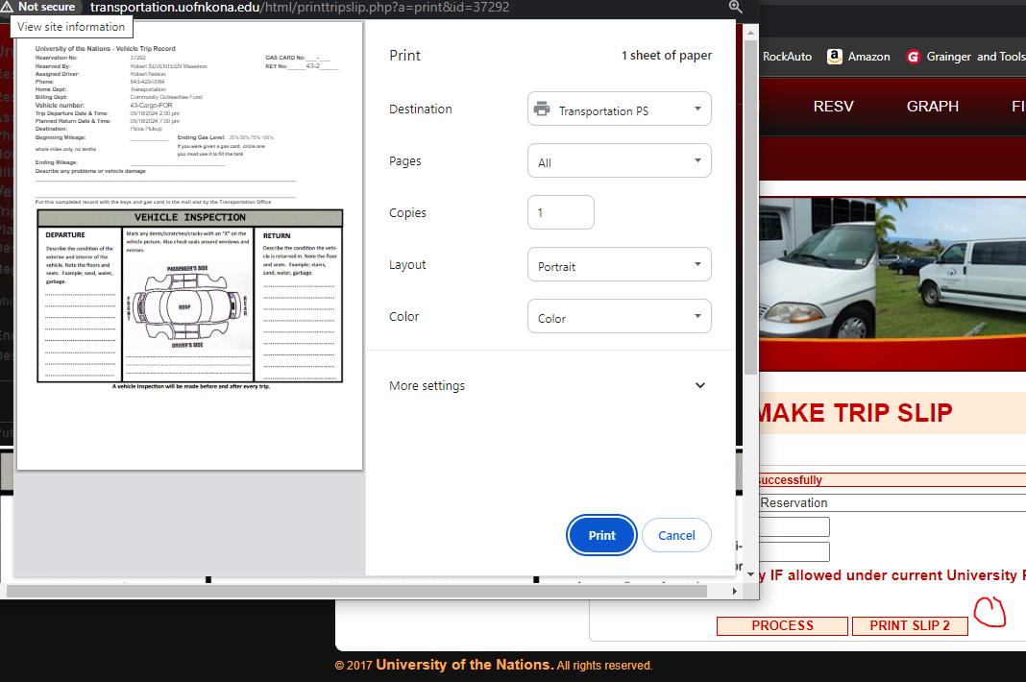

After printing I`m left with the page

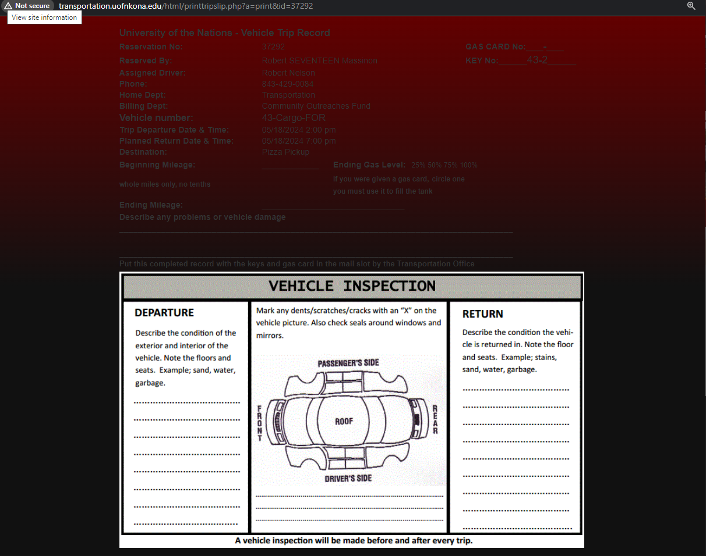

That could have been the intermediate screen, with the print button.

<http://transportation.uofnkona.edu/html/add_tripdetails.php>

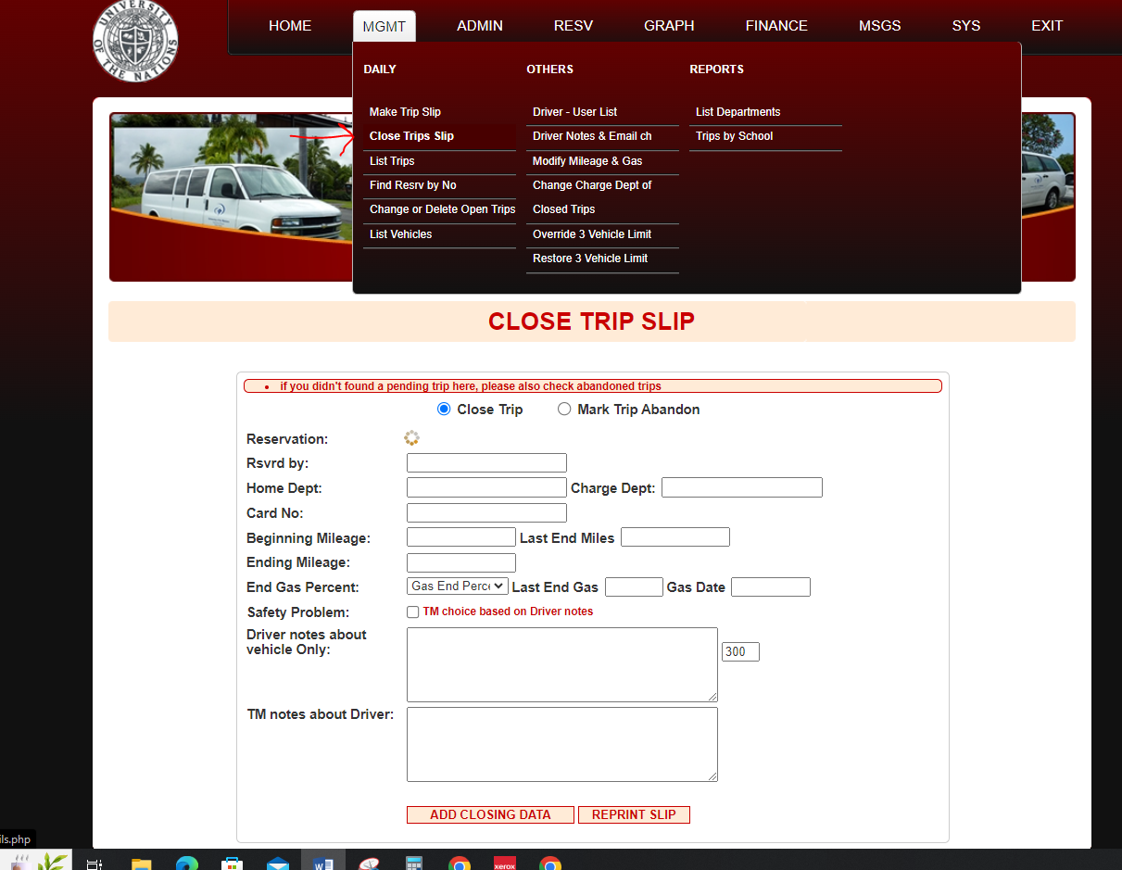

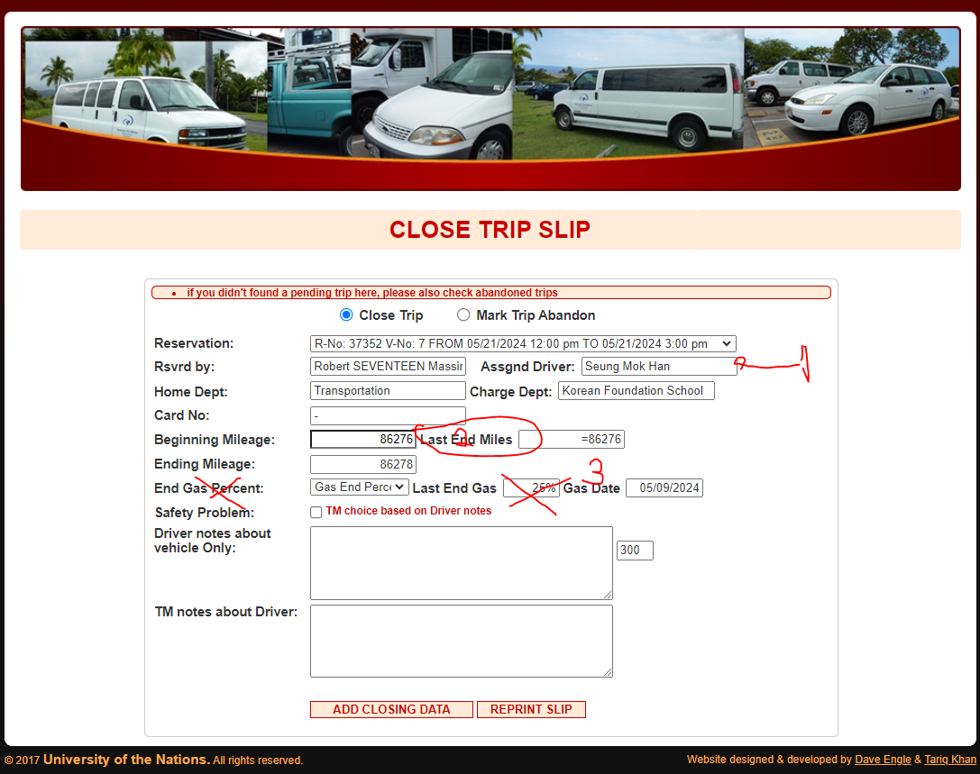

1 Be able to change driver and save if someone stepped in for someone else.

2 Ensure starting and ending miles must align, so they enter trips in chronological order.

3. Last Card Date – When someone clicked the fuel card was present (New field)

<http://transportation.uofnkona.edu/html/list_dept_cost.php>

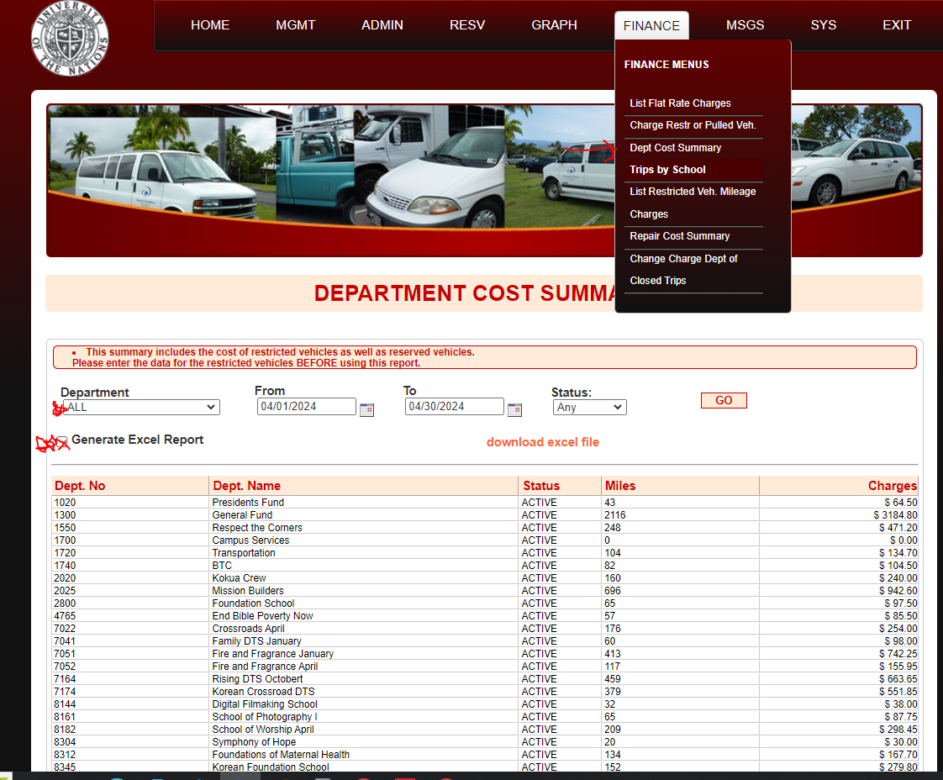

Downloads file and sends to finance for each department.

<http://transportation.uofnkona.edu/html/list_vehicles.php>

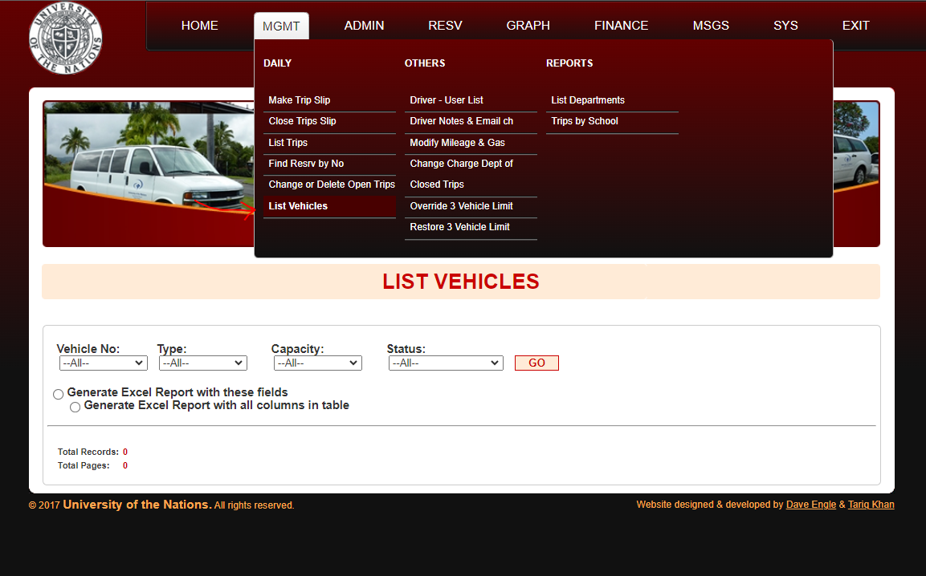

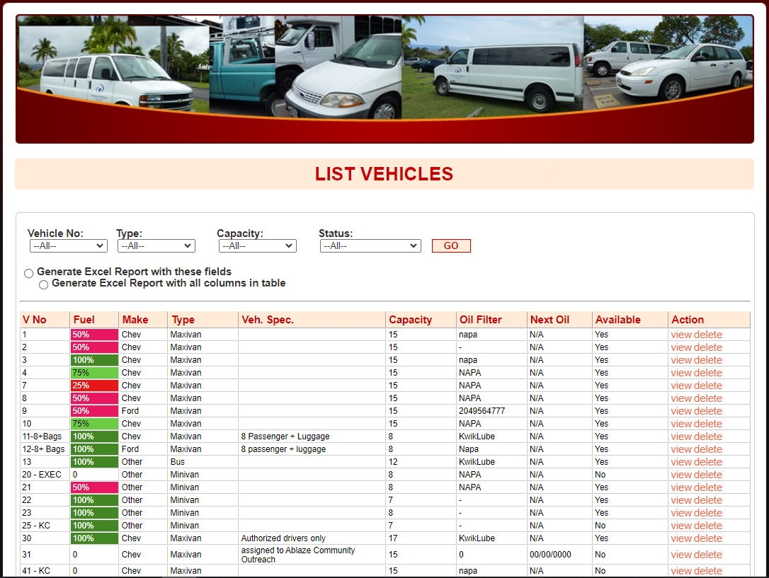

<http://transportation.uofnkona.edu/html/addvehicle.php>

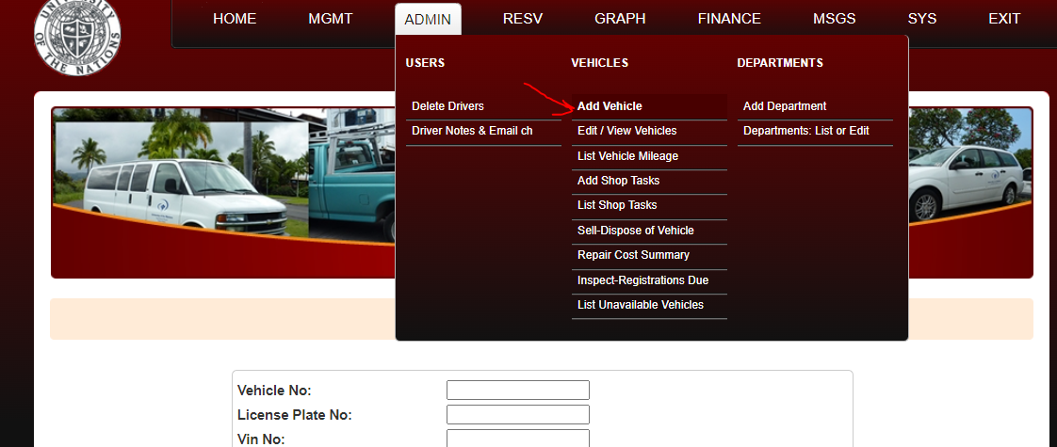

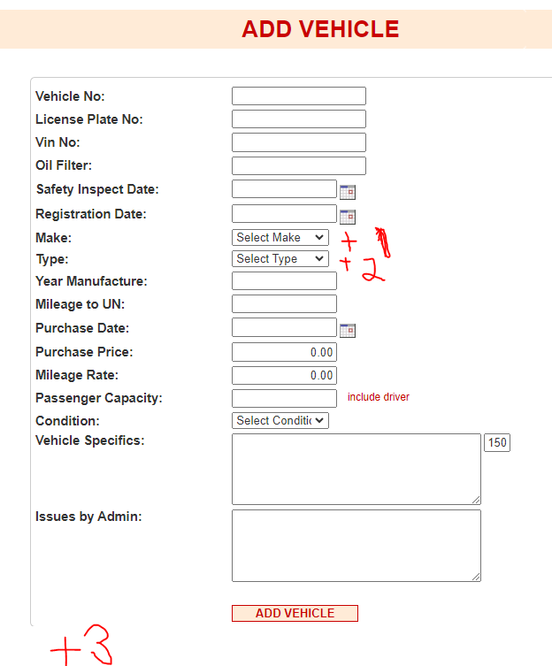

1 – More opions in list

2 – More options/ modify list

3 – New fields

* Air filter part number

* Fuel filter part number

* Windshield Wiper Size

* Tire Size

* Recommended Tire Pressure

Should also be on trip slip.

<http://transportation.uofnkona.edu/html/edit_vehicle.php>

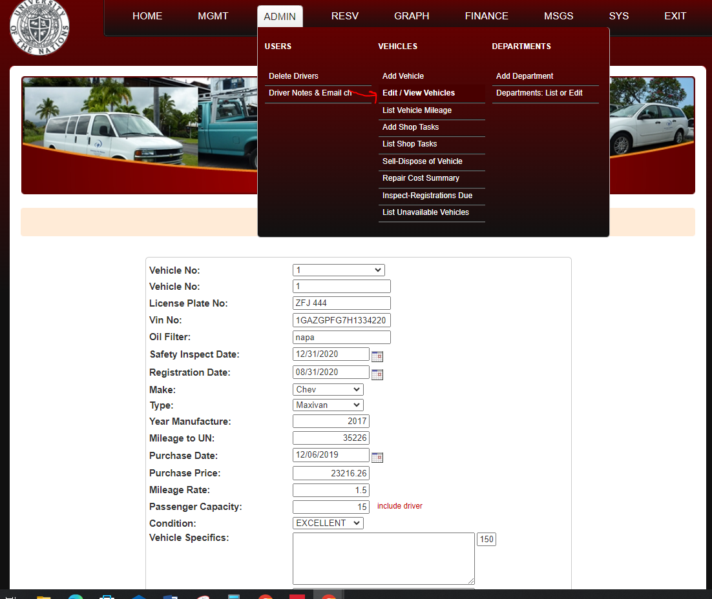

Add everything from the creation screen.

<http://transportation.uofnkona.edu/html/add_dept.php>

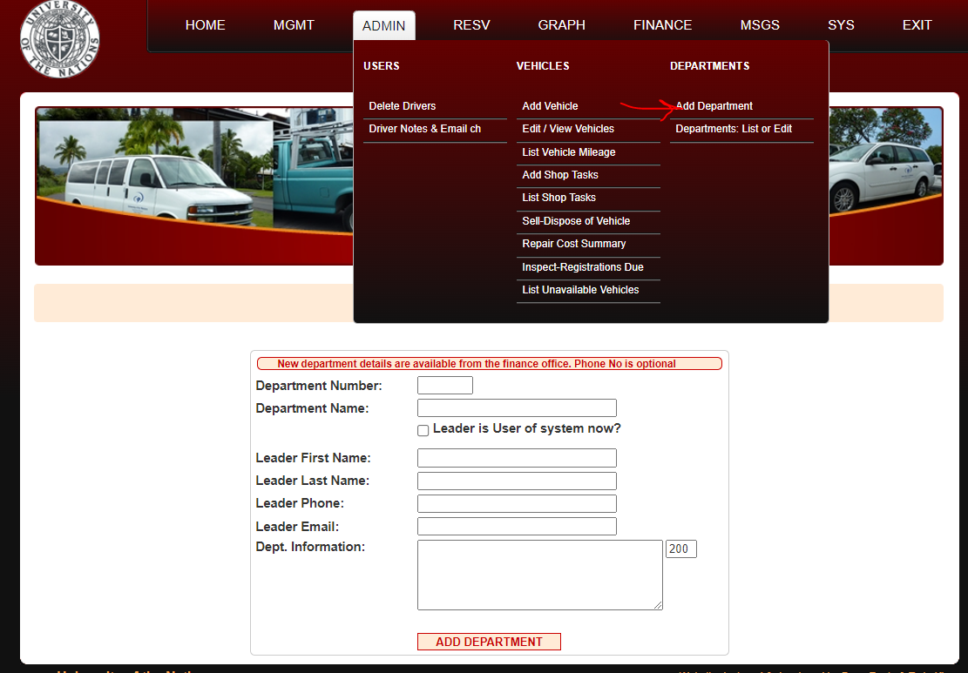

Good as it is.

<http://transportation.uofnkona.edu/html/list_users.php>

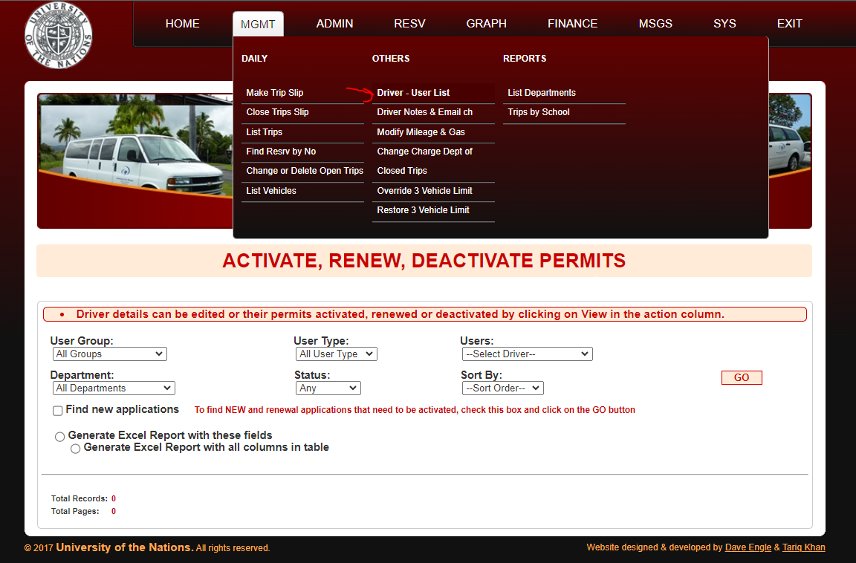

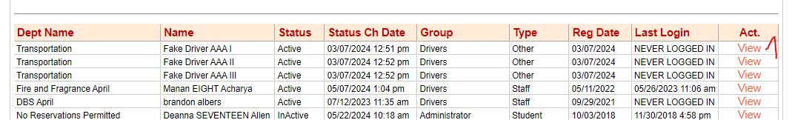

1 – Open view in new tab.

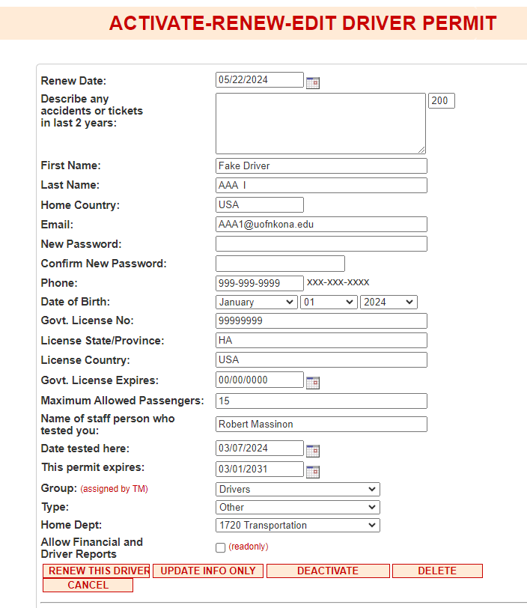

View is ok as is.

<http://transportation.uofnkona.edu/html/list_dept.php>

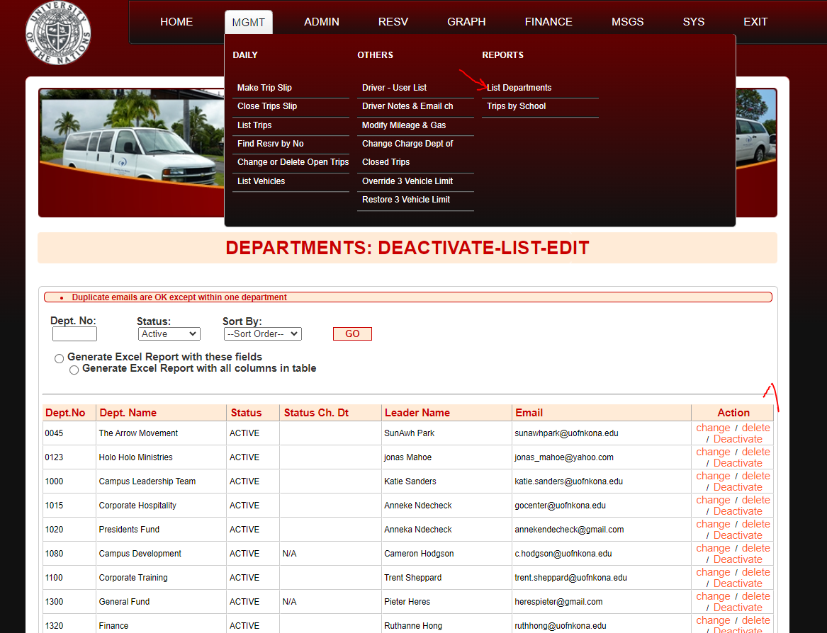

1 – Open in new tab.

<http://transportation.uofnkona.edu/html/srvc_resv.php>

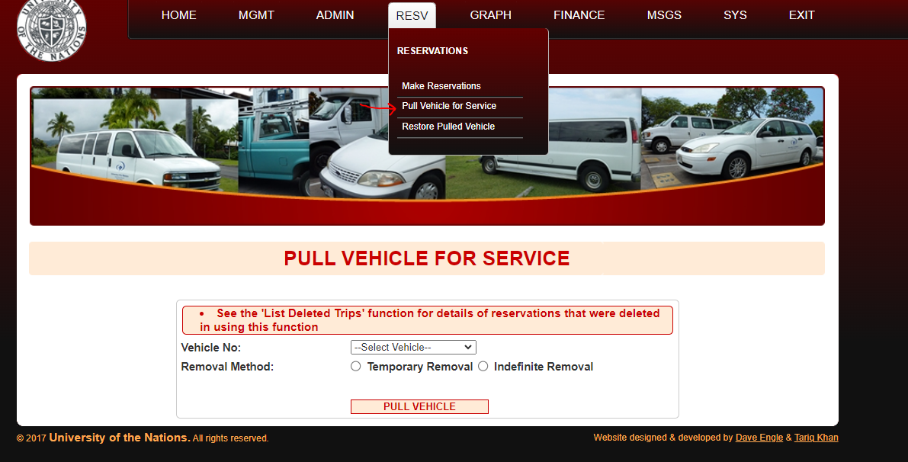

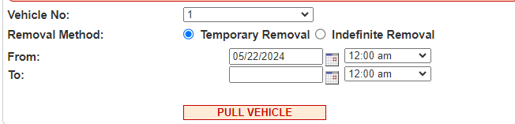

From/To only displays for Temporary Removal.

Automatically online again after limit, would like to have a process for this, reminder/extension, or some such.

<http://transportation.uofnkona.edu/html/srvc_resv_cncl.php>

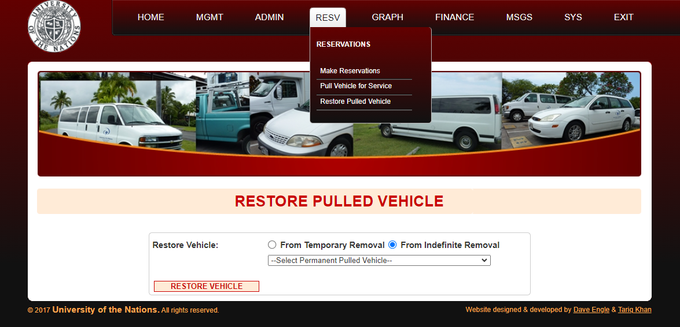

Pull permanently or delete?

<http://transportation.uofnkona.edu/html/adduser_01.php>

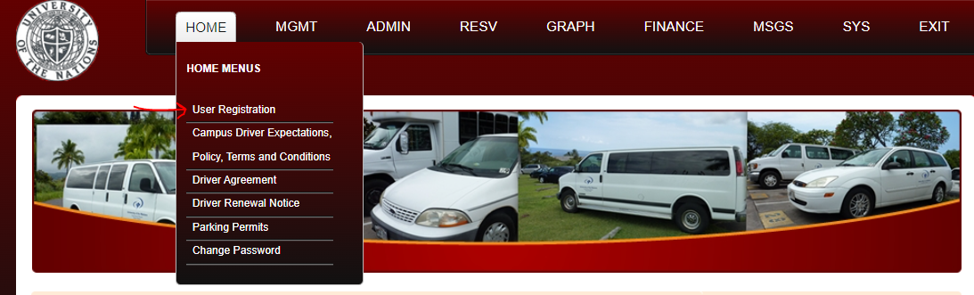

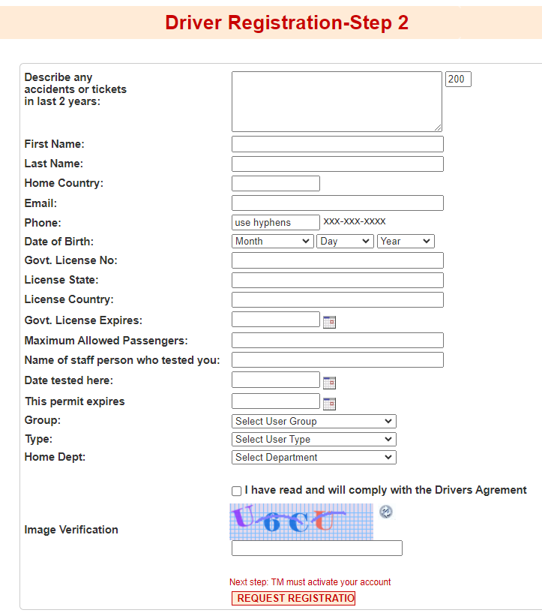

Would like to have the leaders/others add people, using the same form that he has in Excel.

I would also like for people to see and sign the Campus Driver Information.

